HTML Paragraph

**Table of content**

* What is HTML Paragraph?
* What is the use of br tag in HTML Paragraph?
* What is the concept of hr tag in HTML Paragraph?
* What is the use of align attribute in HTML Paragraph?
* What is the concept of pre element in HTML Paragraph?

**What is HTML Paragraph?**

HTML <p> tag is use for representing paragraph. If you want to write a paragraph in your html document then paragraph tag is used.

**Syntax-**

<P>Write your paragraph here. </P>

**Example-**

<!DOCTYPE html>

<html>

  <head>

    <title>Paragraph tag</title>

  </head>

  <body>

    <h2>Geeky4u.com (Learn with Passion)</h2>

    <p>

      Geeky4u.com (Learn with Passion). This is a best platform where we are

      providing best study material, best content so that it is easy for you to

      learn everything and no one will stop you to become a master in

      programming language

    </p>

  </body>

</html>

**Output –**

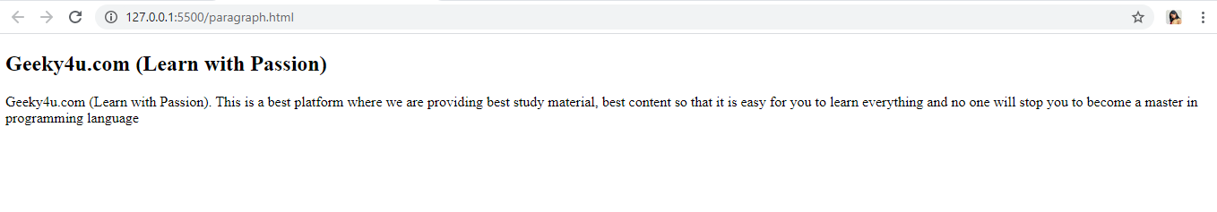

**Example Explain-**

In the above example, Whatever the content or text written in between <p> </p> are consider as a paragraph and it will display on your browser in the format like paragraph.

**What is the use of br tag in HTML Paragraph?**

In HTML Paragraph br tag is use for line break. If you wish to write a song, address or a poem them the format for the poem or song must need line break. For the line break br tag is use. Br tag does not consist of closing tag. Br tag is use at the end of the line where you want to break the particular line with no closing tag. It is very easy to use br tag in HTML paragraph and make your paragraph so attractive and user efficient.

**Syntax-**

Line or text <br>

**Example-**

<!DOCTYPE html>

<html lang="en">

<head>

    <meta charset="UTF-8">

    <meta name="viewport" content="width=device-width, initial-scale=1.0">

    <title>br tag</title>

</head>

<body>

    <p>

    GEEKY4U.com (learn with passion) <br>

    GEEKY4U.com (learn with passion) <br>

    GEEKY4U.com (learn with passion) <br>

    GEEKY4U.com (learn with passion) <br>

    </p>

</body>

</html>

**Output-**

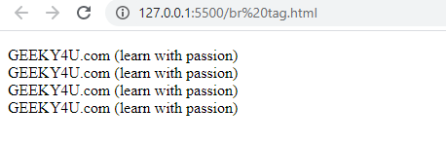

**What is the concept of hr tag in HTML Paragraph?**

Horizontal rule in html is use in paragraph, if user wish to add some line spacing between the paragraph like shift spacing or thematic break then the concept of horizontal rule is used. In HTML <hr> tag represents horizontal rule in your html document. <hr> tag use in between the paragraph tag for providing line spacing between the paragraph. <hr> tag does not have end tag.

**Example-**

<!DOCTYPE html>

<html>

<head>

            <title>hr tag</title>

</head>

    <body>

        <h1>My main heading</h1>

        <p>

        Horizontal rule in html is use in paragraph,

        if user wish to add some line spacing between the paragraph

        like shift spacing or thematic break then the concept of horizontal rule is used.

        </p>

        <hr>

        <p>

        In HTML <hr> tag represents horizontal rule in your html document.

        <hr> tag use in between the paragraph tag for providing line spacing between the paragraph.

        <hr> tag does not have end tag.

        </p>

    </body>

</html>

**Output-**

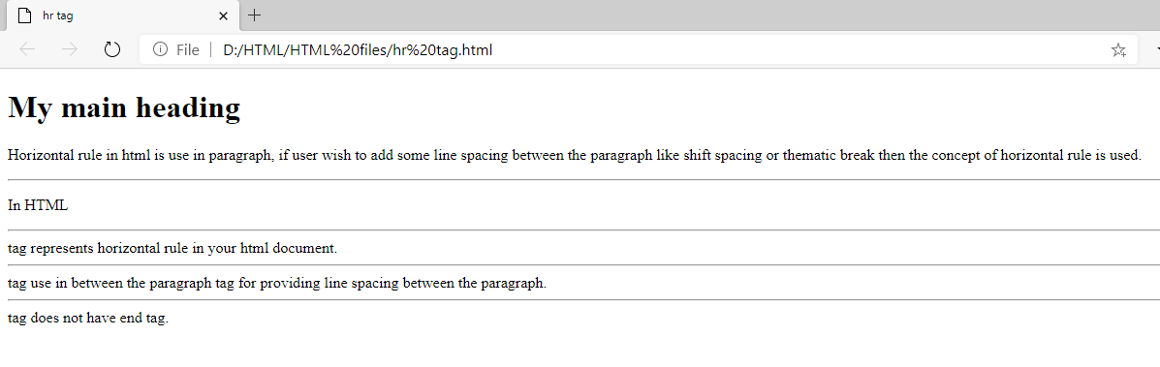

**What is the use of align attribute in HTML Paragraph?**

In HTML Paragraph, align is a special attribute which is given to the text of your HTML Paragraph for making your text document Right align, Left align or center align or justify respectively.

There are 4 types of align attribute in HTML paragraph-

**Right align**- Right align attribute is use to set your HTML paragraph into right align. Whatever the text you will write under the right align it will display at the right corner of your HTML page.

**Left align-** Left align attribute is use to set your HTML paragraph into left align. Whatever the text you will write under the left align it will display at the very left corner of your HTML page.

**Center align-** Center align attribute is use to set your HTML paragraph into center align. Whatever the text you will write under the center align it will display at the center of your HTML page.

**Justify-** It will help your HTML paragraph to Extend your paragraph text for making the width of all the lines equal.

**Syntax-**

<p align= ”left”> </p>

<p align= ”right”> </p>

<p align= ”center”> </p>

**Example-**

<!DOCTYPE html>

<html>

<head>

    <meta charset="UTF-8">

    <title>align attribute</title>

</head>

<body>

    <h1> GEEKY4U.com (learn with passion) <h1>

    <h3>

    <p align="left">

     GEEKY4U.com (learn with passion)

    </p>

    <p align="center">

     GEEKY4U.com (learn with passion)

    </p>

    <p align="right">

    GEEKY4U.com (learn with passion)

    </p>

    </h3>

</body>

</html>

**Output-**

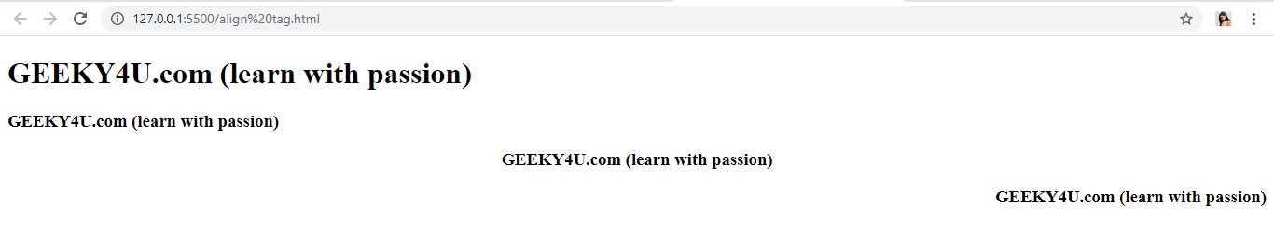

**What is the concept of pre element in HTML Paragraph?**

HTML paragraph does not allow the line spacing or formatted text, whatever you write in the paragraph including spaces, line break etc the browser will display the output without any spacing or line break. Browser will discard all the formatting and display only the plain text. If you wish to write a text in poem format or in song format then pre element is used.

**Syntax-**

<pre> Your text </pre>

**Example-**

<!DOCTYPE html>

<html lang="en">

<head>

    <meta charset="UTF-8">

    <meta name="viewport" content="width=device-width, initial-scale=1.0">

    <title>pre element</title>

</head>

<body>

    <pre>

    GEEKY4U.com (learn with passion)                     GEEKY4U.com (learn with passion)

    GEEKY4U.com (learn with passion)                     GEEKY4U.com (learn with passion)

    </pre>

</body>

</html>

**Output-**

